**Hands-On SQL Tutorial**

**Set Up Dog Shelter Database: CREATE DATABASE**

CREATE DATABASE pet_adoption;



USE pet_adoption;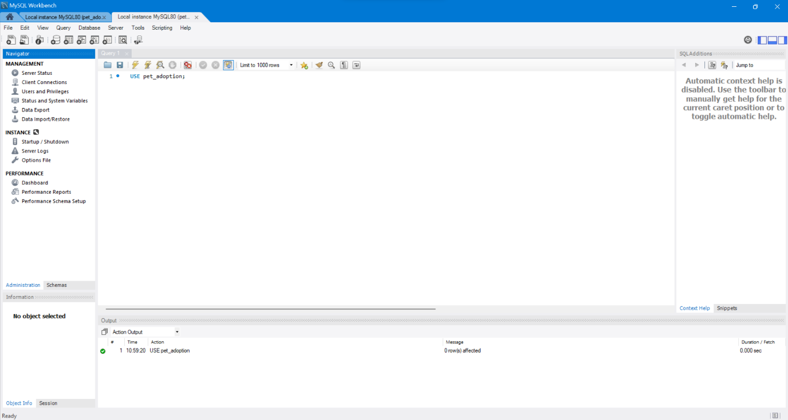

**Table #1: A Table for Animals: CREATE TABLE & UUID**

CREATE TABLE animals (id UUID NOT NULL, name STRING, breed STRING, color STRING, gender STRING, status INTEGER);

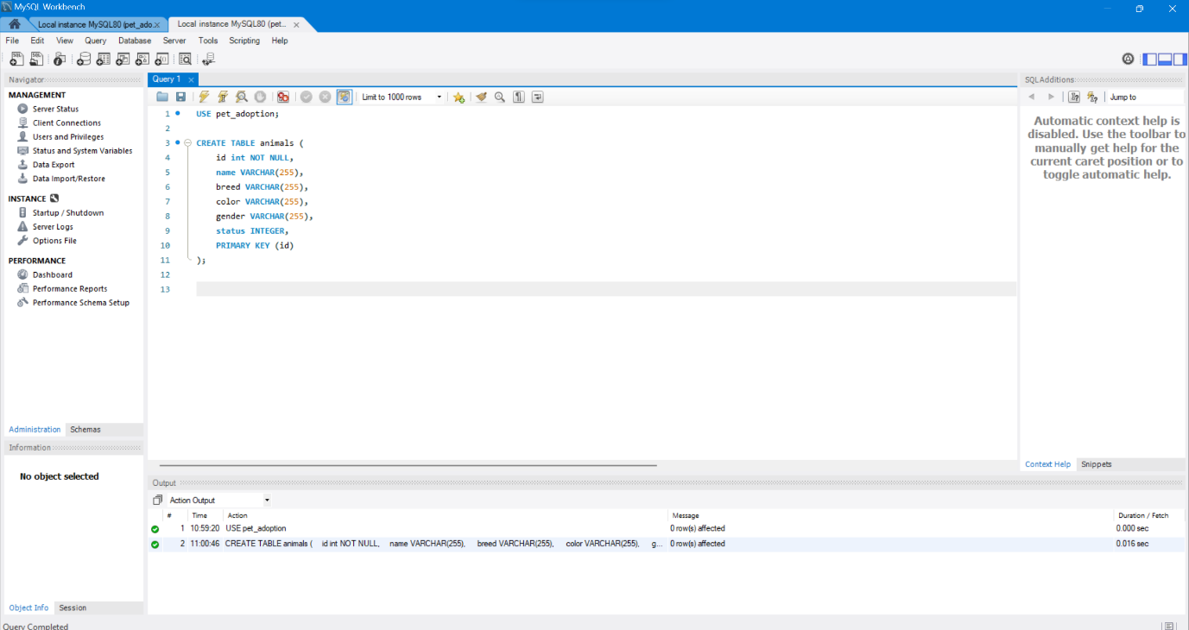

**Table #2: The List of Adoptions: TIMESTAMP**

CREATE TABLE adoptions (animal_id UUID NOT NULL, name STRING, contact STRING, date TIMESTAMP);

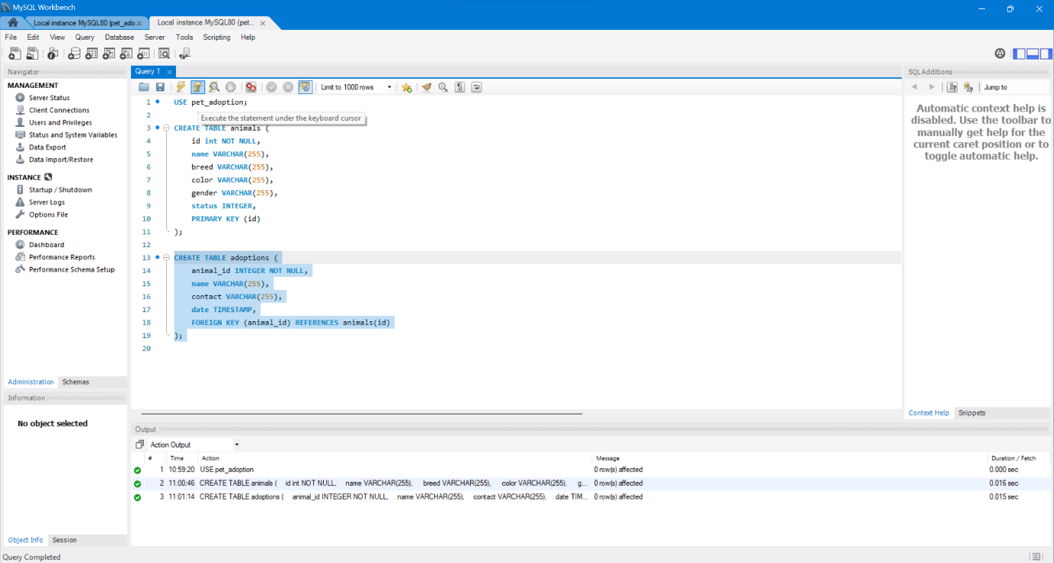**Verify Database Setup: SHOW TABLES & COLUMNS**

SHOW TABLES;

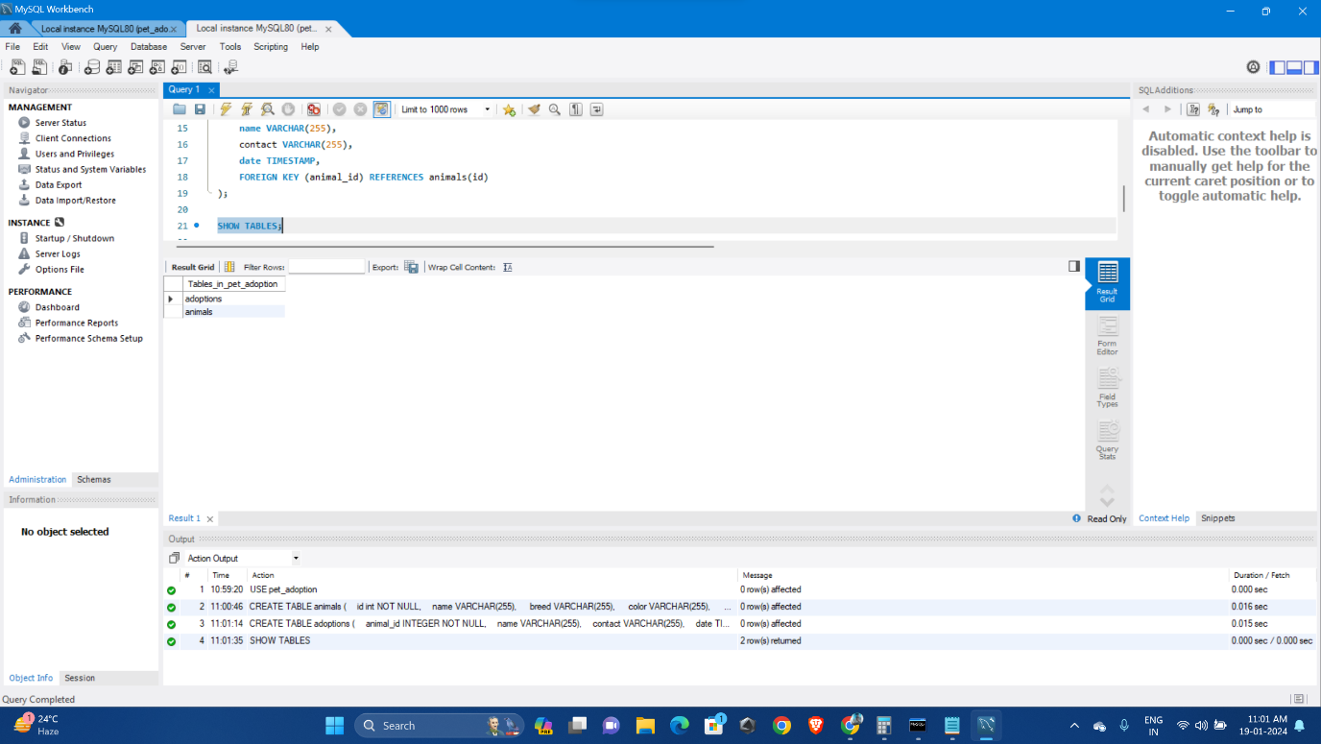

SHOW COLUMNS FROM animals;

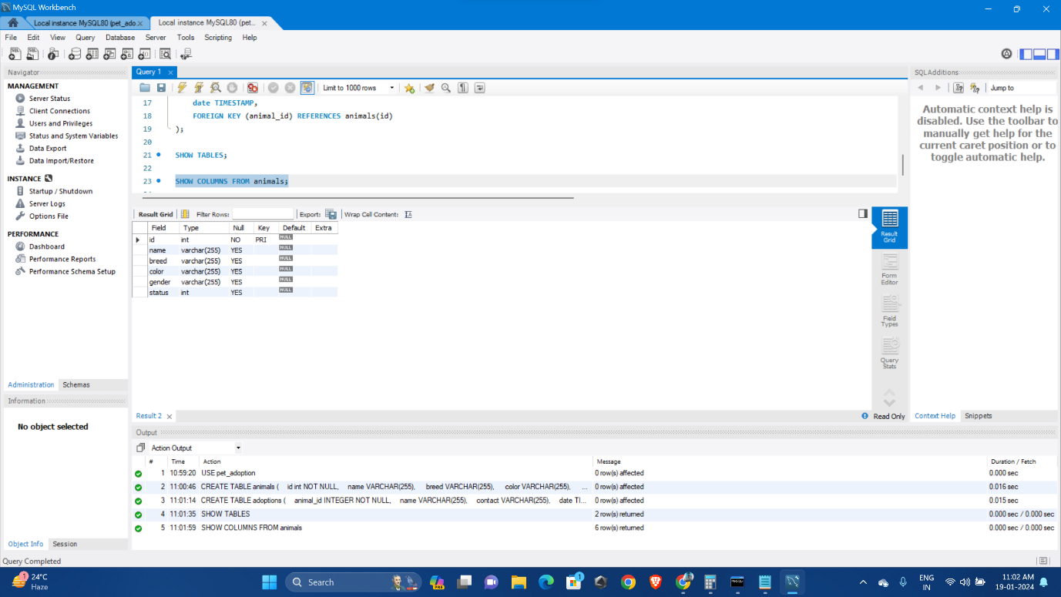

SHOW COLUMNS FROM adoptions;

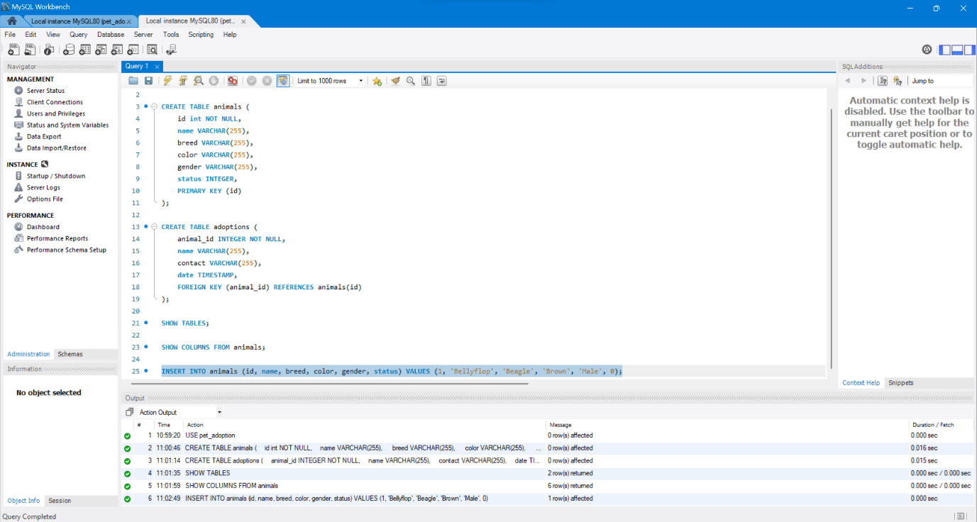

**Add Dogs to Database: INSERT**

INSERT INTO animals (id, name, breed, color, gender, status) VALUES (1, 'Bellyflop', 'Beagle', 'Brown', 'Male', 0);

**Exercise 1: Add All Dogs to the Database**

INSERT INTO animals (id, name, breed, color, gender, status) VALUES (2, 'Bellyflop', 'Beagle', 'Brown', 'Male', 0);

INSERT INTO animals (id, name, breed, color, gender, status) VALUES (3, 'Snowy', 'Husky', 'White', 'Female', 0);

INSERT INTO animals (id, name, breed, color, gender, status) VALUES (4, 'Princess', 'Pomeranian', 'Black', 'Female', 0);

INSERT INTO animals (id, name, breed, color, gender, status) VALUES (5, 'Cricket', 'Chihuahua', 'Brown', 'Male', 0);

INSERT INTO animals (id, name, breed, color, gender, status) VALUES (6, 'Princess', 'Poodle', 'Purple', 'Female', 0);

INSERT INTO animals (id, name, breed, color, gender, status) VALUES (7, 'Spot', 'Dalmation', 'Black and White', 'Male', 0); 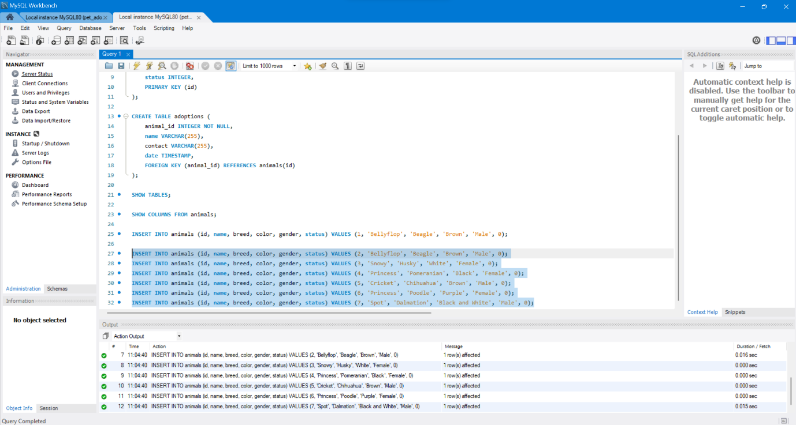

**Retrieve List of Dogs: SELECT * FROM**

SELECT * FROM animals;

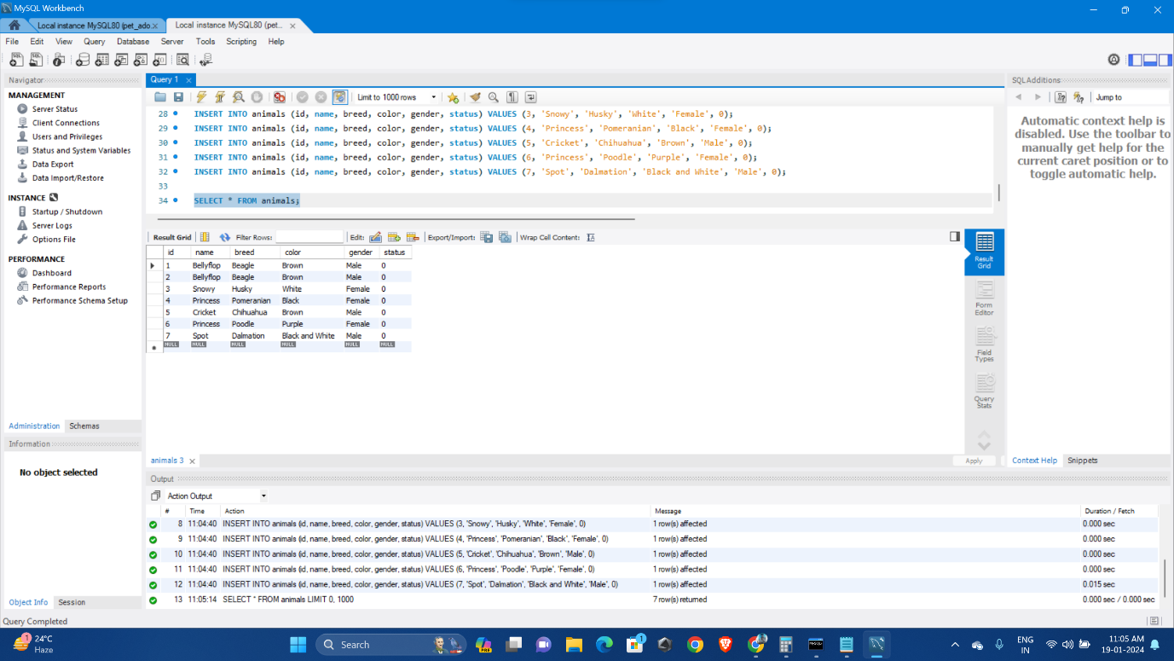

SELECT breed FROM animals;

Get the names of only female dogs by including a WHERE clause:

SELECT name FROM animals WHERE gender = 'Female';

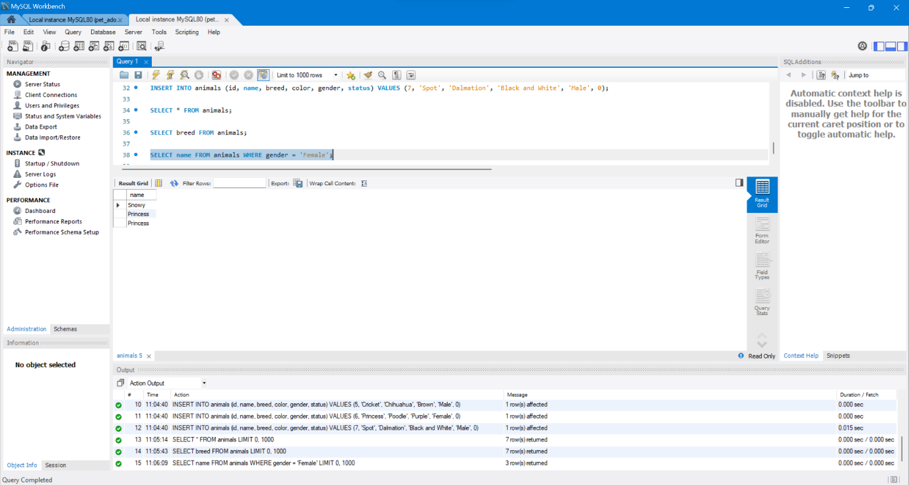

Get the IDs of dogs up for adoption:

SELECT id FROM animals WHERE status = 0;

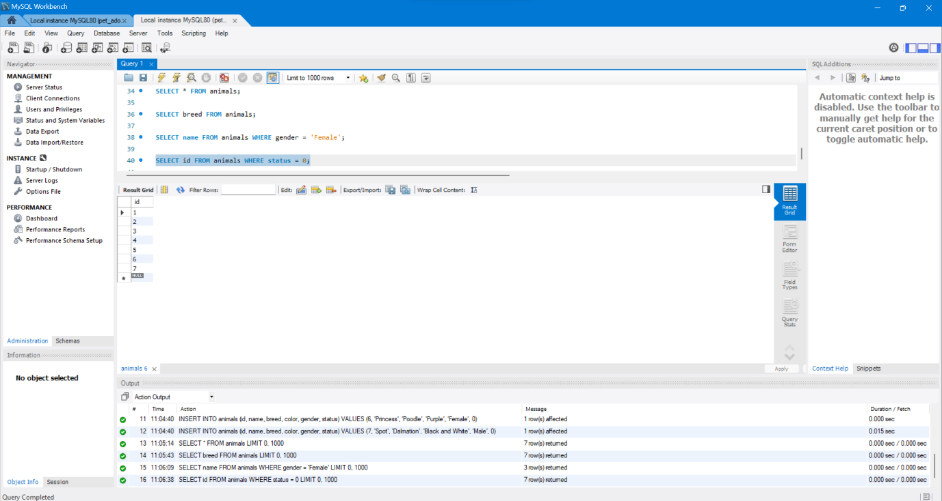

**Update Dogs’ Information: UPDATE & DELETE FROM**

UPDATE animals SET color = 'Brown' WHERE id = 2;

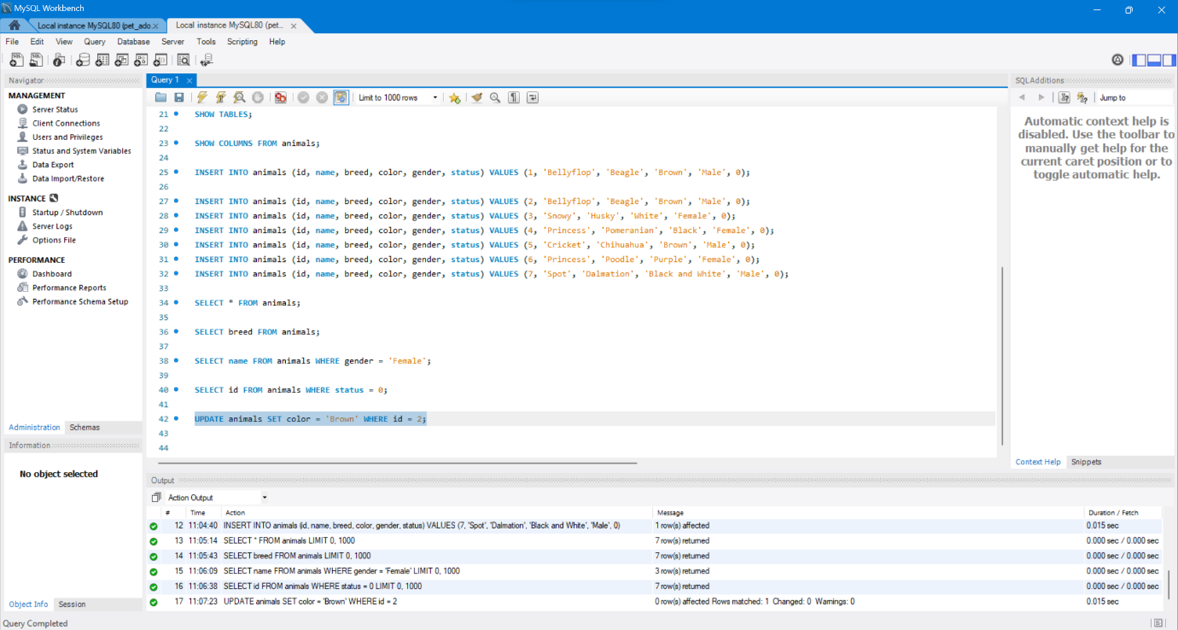

UPDATE animals SET color = 'Brown' WHERE name = 'Princess';

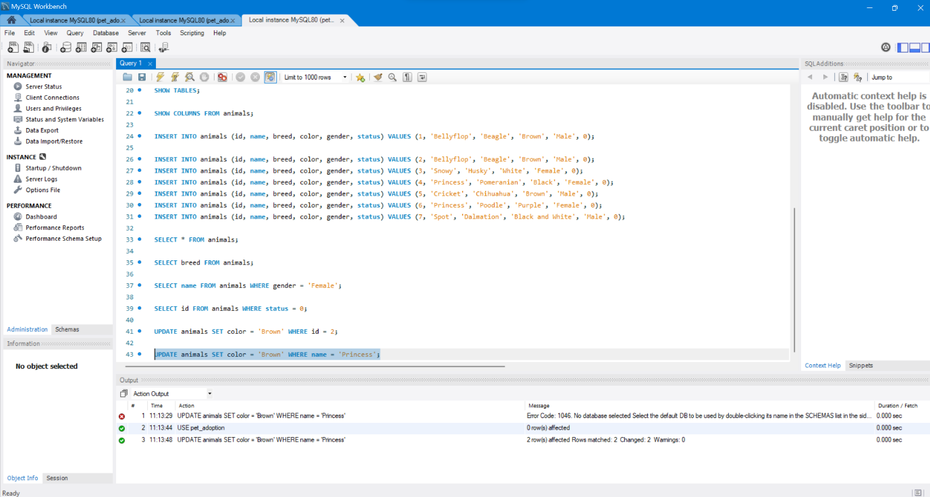

UPDATE animals SET color = 'Brown' WHERE color = 'Purple';

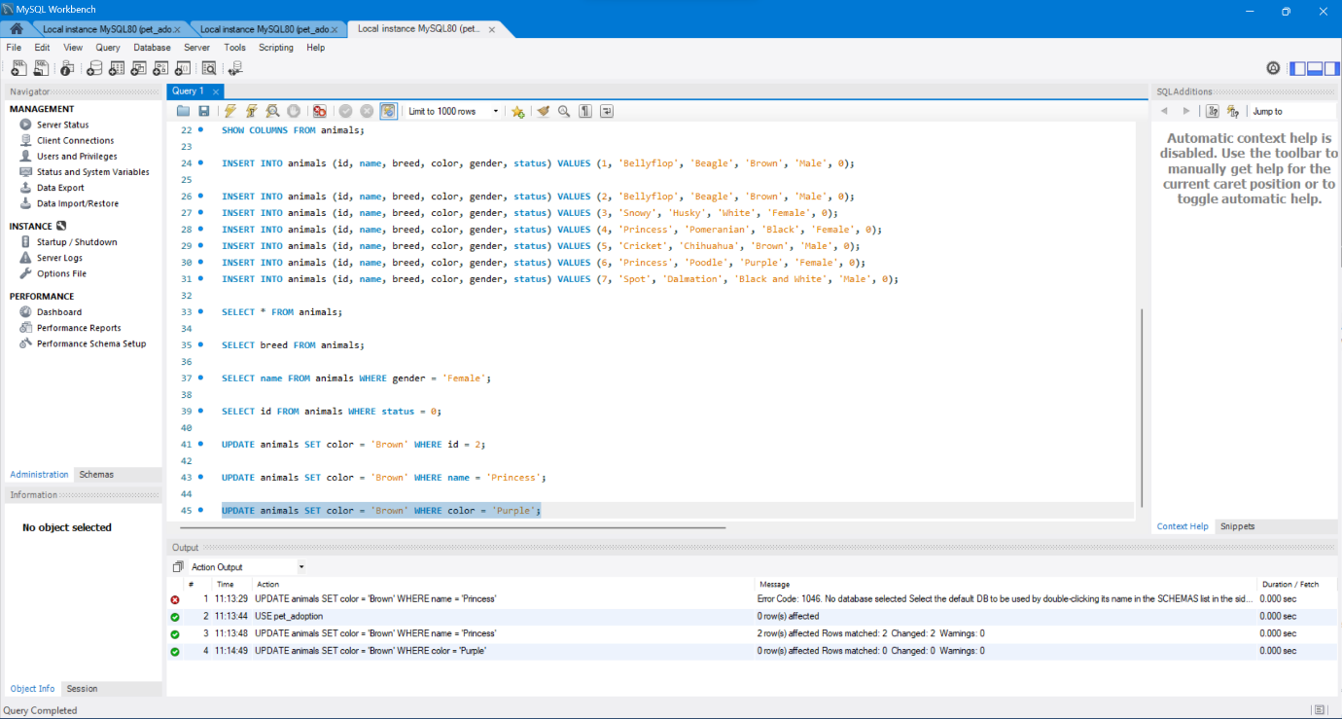

**Our First Shelter Adoption: UPDATE & INSERT**

UPDATE animals SET status = 1 WHERE id = 2;

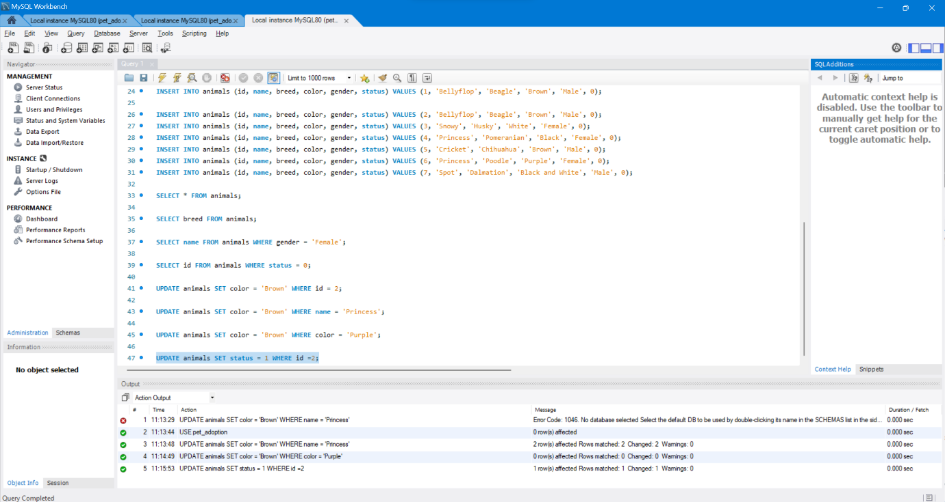

The adoption SQL statement should look like the following:

INSERT INTO adoptions (animal_id, name, contact, date) VALUES (1, 'Pinocchio', 'realboy@cockroachlabs.com', NOW());

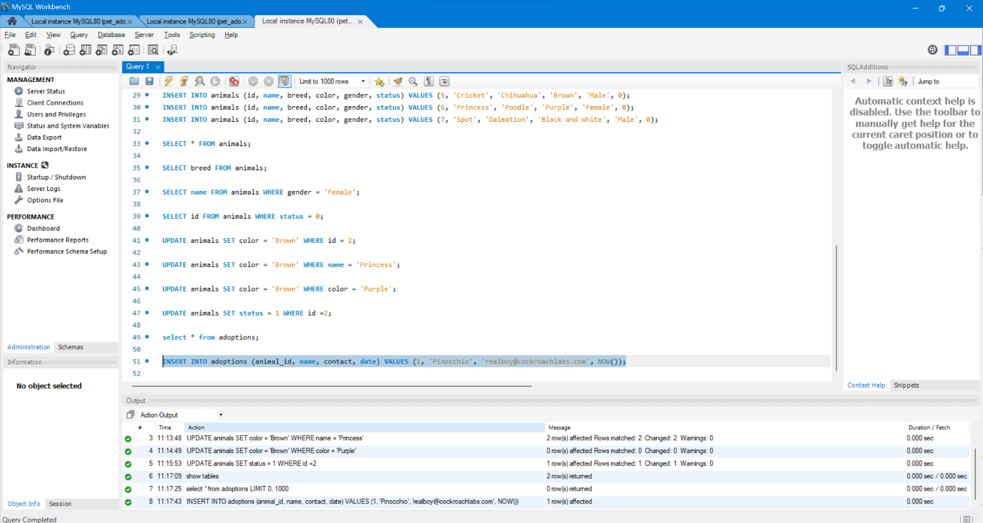

**Exercise 2: Record Adoptions**

UPDATE animals SET status = 1 WHERE id = 2';

INSERT INTO adoptions (animal_id, name, contact, date) VALUES (2, 'Patalie', 'poodlequeen@cockroachlabs.com', NOW());

UPDATE animals SET status = 1 WHERE id = 3;

INSERT INTO adoptions (animal_id, name, contact, date) VALUES (3, 'Ella', 'ellacrew@cockroachlabs.com', NOW());

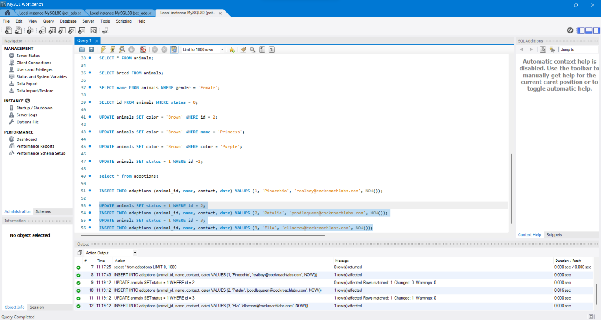

**Verify Changes: ORDER BY**

SELECT * FROM adoptions;

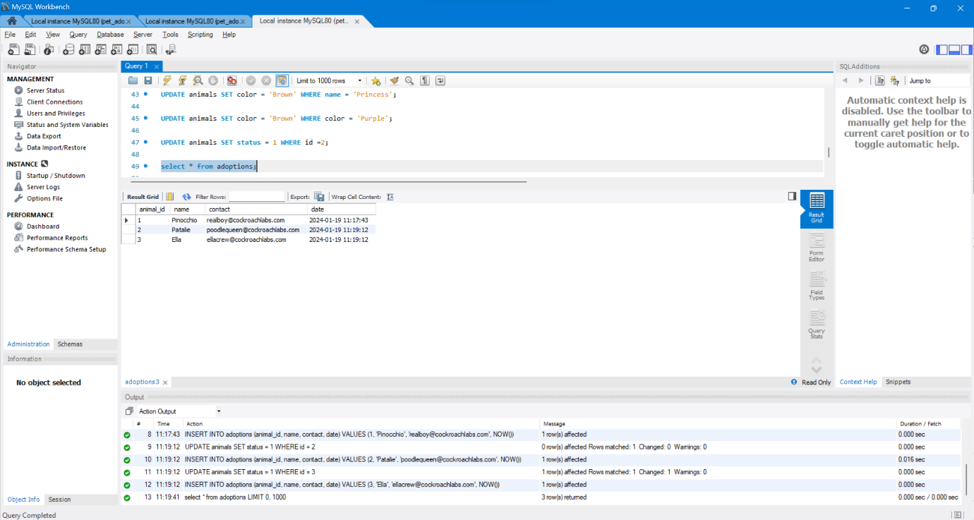

SELECT * FROM adoptions ORDER BY date DESC;

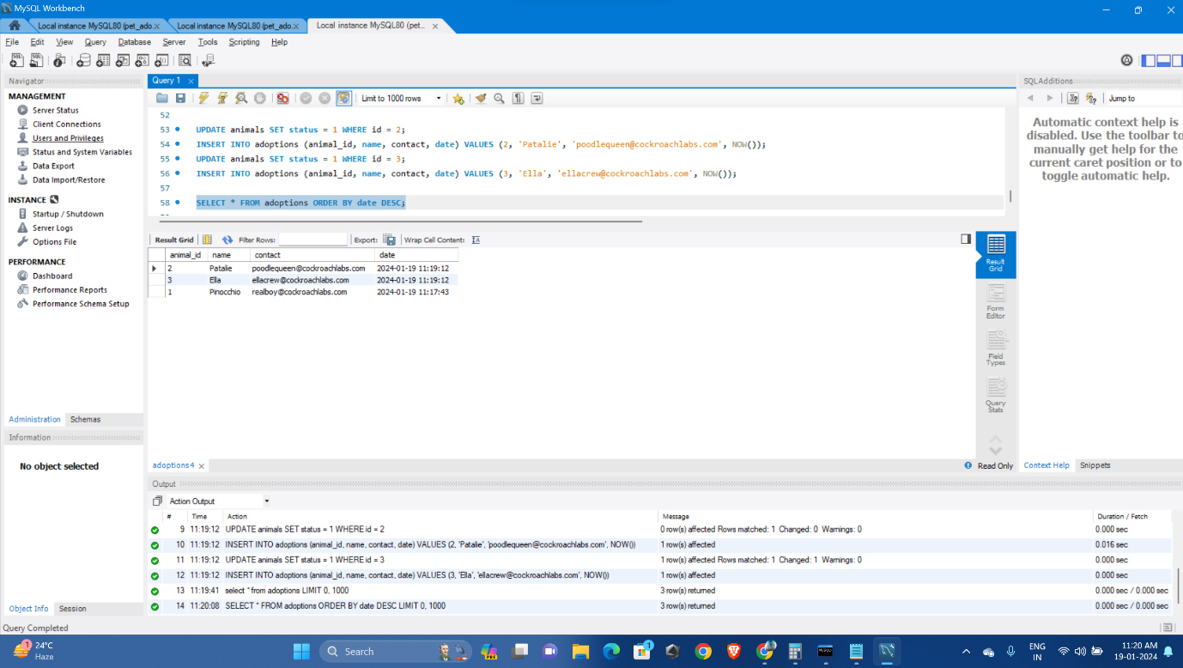

SELECT * FROM animals WHERE status = 1;

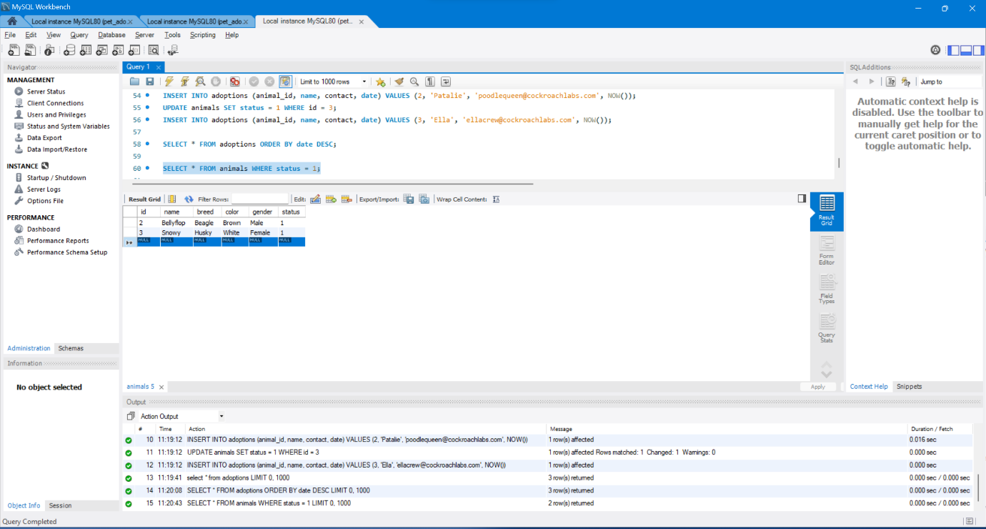

**Advanced: Now Accepting Cats for Adoption**

**Add a Table Column: ALTER TABLE**

First, we will need to add a new species column to the animals table to track whether an animal entry is for a dog or a cat. This can be done using the ALTER TABLE command:

ALTER TABLE animals ADD COLUMN species VARCHAR(255);

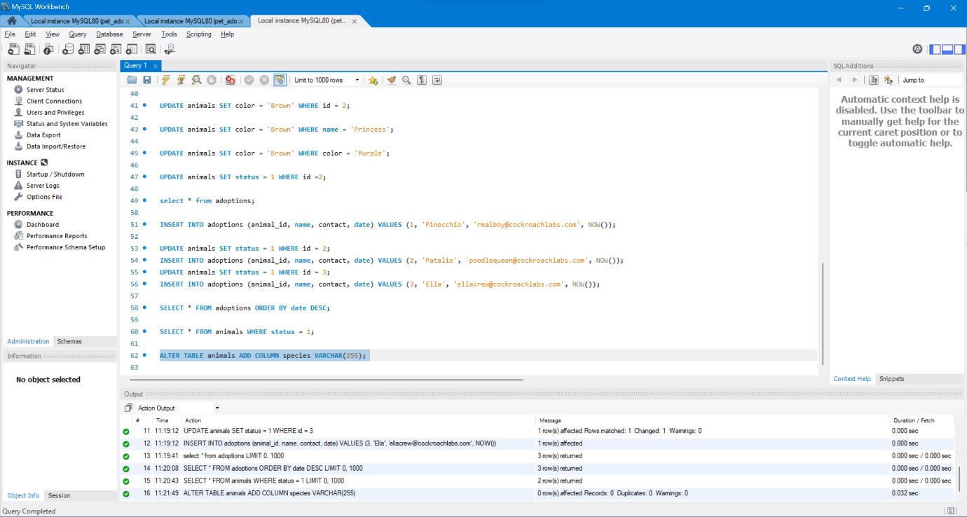

And we can verify that the table was properly updated using the SHOW COLUMNS command.

SHOW COLUMNS FROM animals;

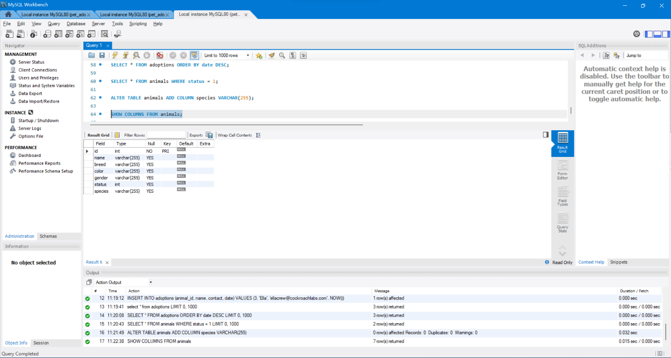

**Set All Current Animals to “Dog”: UPDATE**

Then run the following query to specify “Dog” for all of the current animals in the database:

UPDATE animals SET species = 'Dog';

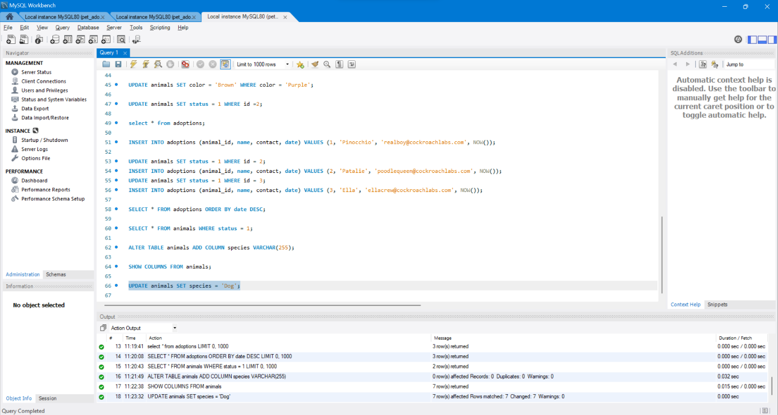

**Bring In The Cats**

**Exercise 3: Add All Cats to the Database**

INSERT INTO animals (id, name, species, breed, color, gender, status) VALUES 8, 'Meowmix', 'Cat', 'Munchkin', 'Yellow', 'Female', 0);

INSERT INTO animals (id, name, species, breed, color, gender, status) VALUES (9, 'Ash', 'Cat', 'Persian', 'Gray', 'Female', 0);

INSERT INTO animals (id, name, species, breed, color, gender, status) VALUES (10, 'Tiger', 'Cat', 'Bengal', 'Brown', 'Male', 0);

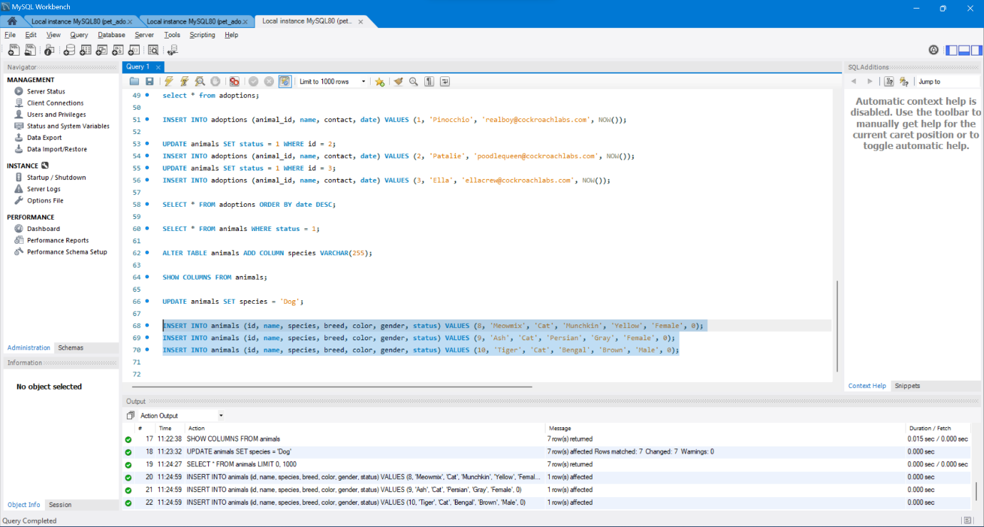

Just to be sure, let’s check that the cats were added to the database properly.

SELECT * FROM animals;

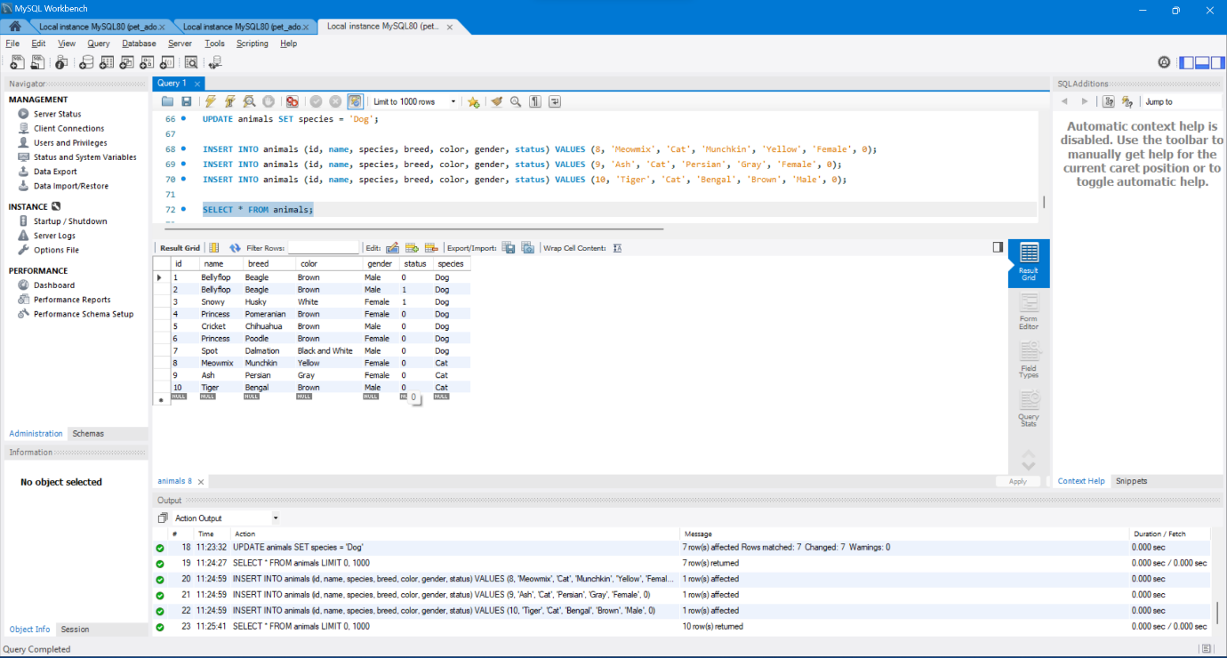

**Advanced: Expand to Multiple Locations**

**A Table for Shelters: ALTER TABLE … ADD COLUMN**

CREATE TABLE shelters (id INTEGER, name STRING, location STRING);

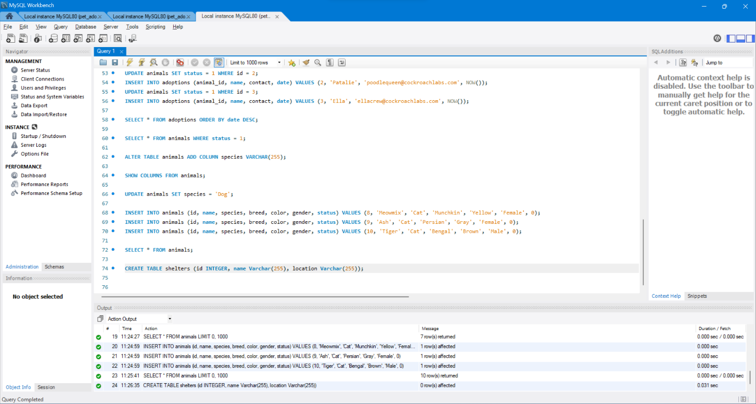

Let’s add our current and first shelter, Animals 4 Homes, located in Red City:

INSERT INTO shelters (id, name, location) VALUES (1, 'Animals 4 Homes', 'Red City');

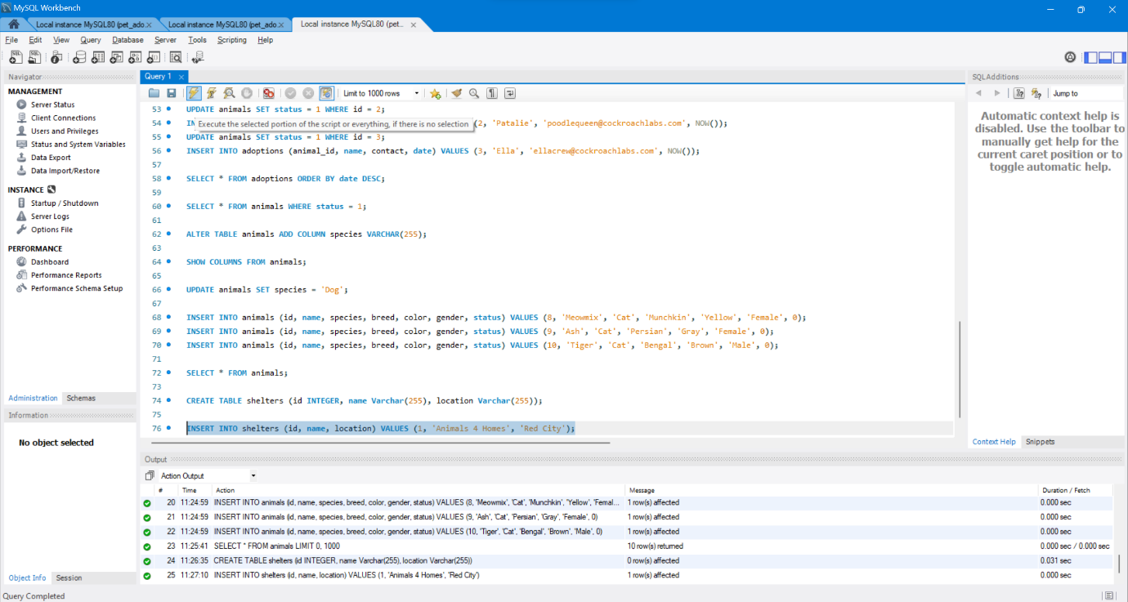

ALTER TABLE animals ADD COLUMN shelter INTEGER;

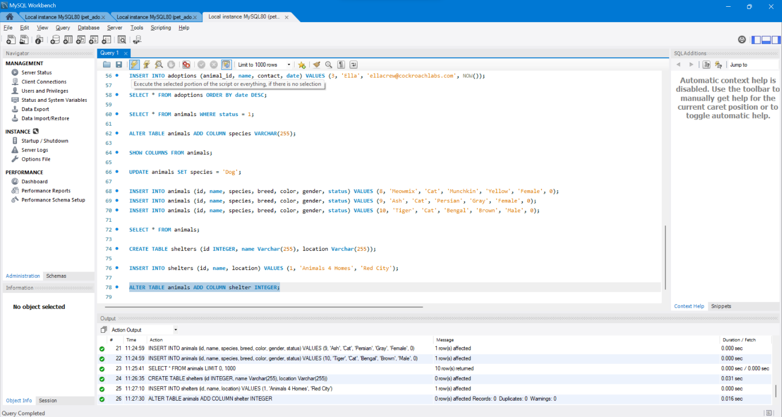

UPDATE animals SET shelter = 1;

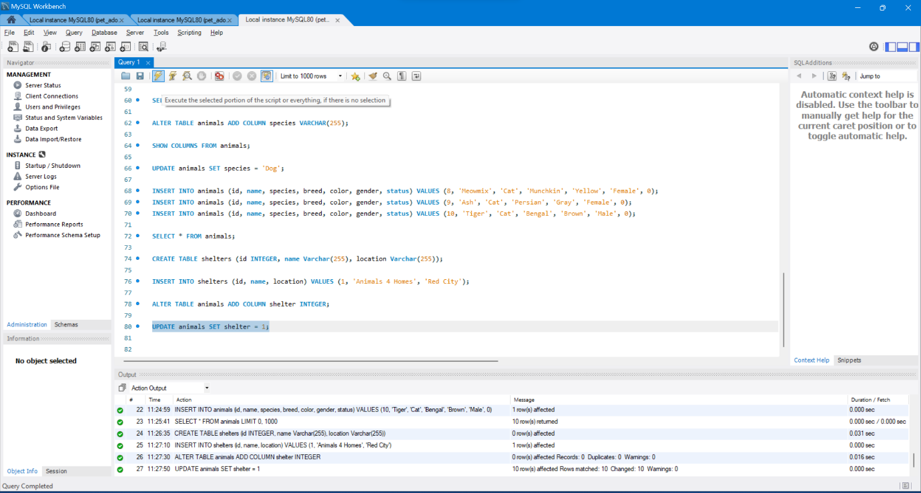

Then we can create entries for the other two shelters joining our efforts for pet adoption: Adopt A Buddy and Fluffy Animals:

INSERT INTO shelters (id, name, location) VALUES (2, 'Adopt A Buddy', 'Green Town');

INSERT INTO shelters (id, name, location) VALUES (3, 'Fluffy Animals', 'Blue Hills');

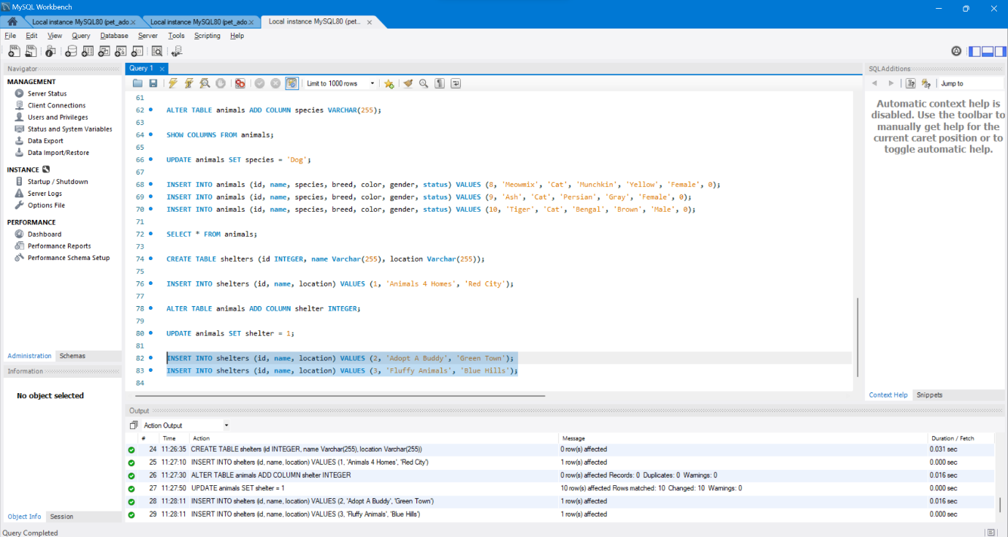

**New Animals for New Homes**

Our new animal shelters are taking in some new animals who are looking for loving homes.

**Exercise 4: Add Many Types of Animals**

INSERT INTO animals (id, name, shelter, species, breed, color, gender, status) VALUES (11, 'Snoops', 2, 'Dog', 'Beagle', 'Brown', 'Male', 0);

INSERT INTO animals (id, name, shelter, species, breed, color, gender, status) VALUES (12, 'Salt', 2, 'Cat', 'Turkish Angora', 'White', 'Female', 0);

INSERT INTO animals (id, name, shelter, species, breed, color, gender, status) VALUES (13, 'Fuzz', 3, 'Dog', 'Papillon', 'Gray', 'Male', 0);

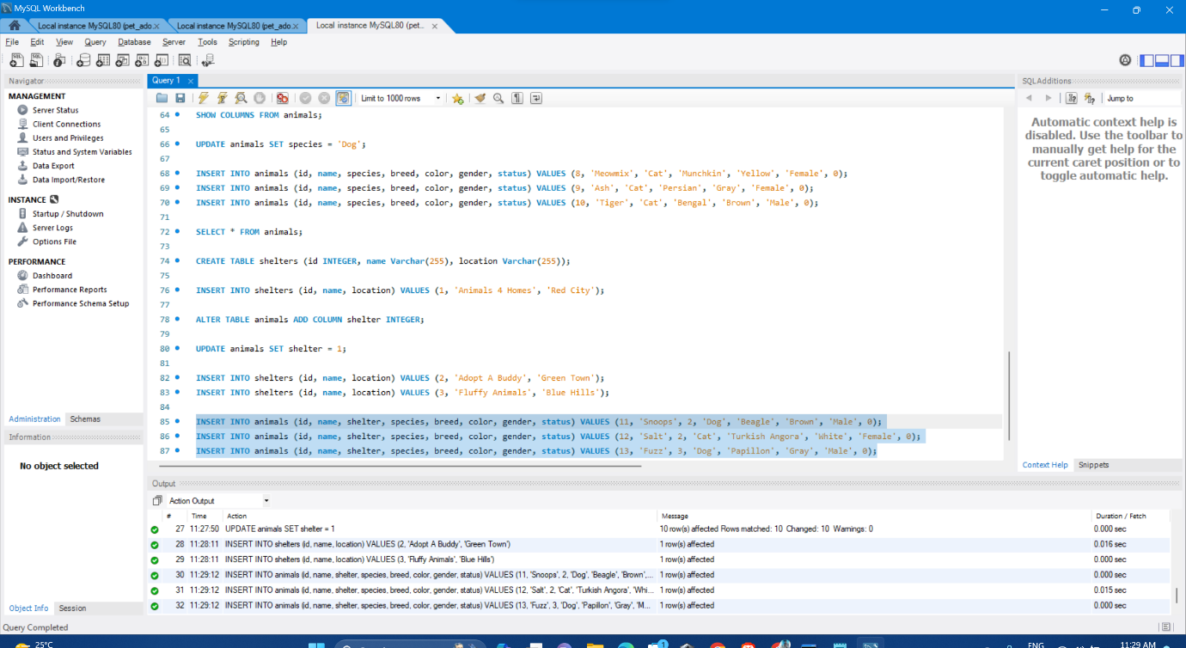

**More Advanced SQL: Indexes and Joins**

**What’s an Index?**

An index basically hints to the database that a particular column is important, and should be used to help sort and filter through the data. This tells the database tasks to add some indexing information each time some data is added or updated. This way, the whole database can run more efficiently, and queries through the data can be completed much faster. In our case, we can create an index for the shelter column in the animals table because that will be one of the key ways to divide up the data. For more experiments with indexes, pop over to Full Text Indexing and Search.

To do so, we can run this command:

CREATE INDEX animal_shelter ON animals (shelter);

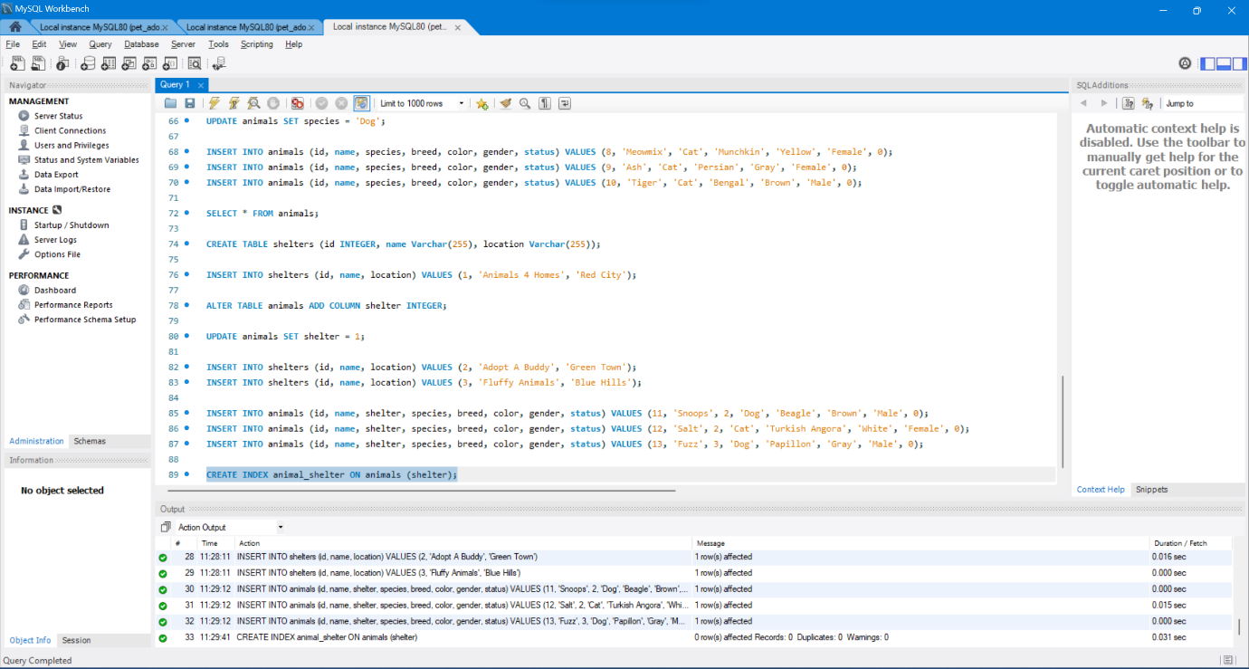

#### Complex Queries with JOIN

Finally, using JOIN, we can query across multiple tables and retrieve not only each animal’s information but their shelter in a single SQL statement instead of doing the work ourselves.

It looks a bit like this:

SELECT * FROM animals JOIN shelters ON animals.shelter = shelters.id;

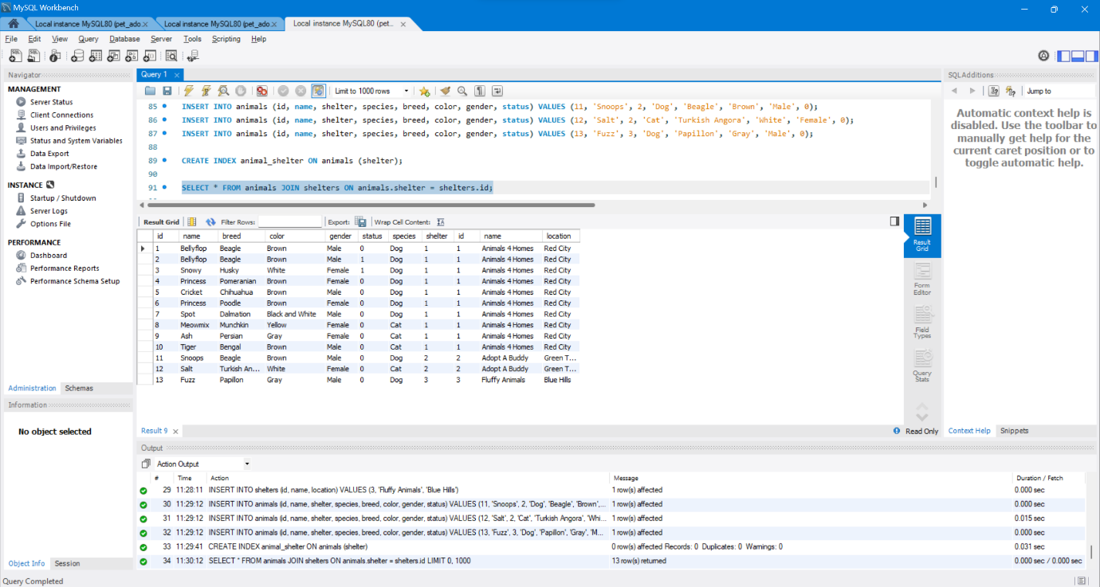

The ON clause above specifies that the shelter column in the animals table will match an id in the shelters table. That will be the link that makes the combined table query result possible.

#### Exercise 5: Get list of all animals

SELECT * FROM adoptions JOIN animals ON adoptions.animal_id = animals.id WHERE animals.shelter = 1;

